 | Assignment No. 1  Semester: Spring 2021  CS301 – Data Structures | Total Marks: 20  Due Date: 18/05/2021

Solution

NAME: TAMKEEN SAJJAD
ID: MC200400003

Course: MIT
Program Code:
#include<iostream>
#include <string>

using namespace std;

struct node
{
int courseID;
string studentName;
node *next;
};

class list
{
private:
node *head, *tail;
public:
list()
{
head=NULL;
tail=NULL;
}
void createnode(int value, string name)
{
node *temp=new node;
temp->courseID=value;
temp->studentName=name;
temp->next=NULL;
if(head==NULL)
{
head=temp;
tail=temp;
temp=NULL;
}
else
{
tail->next=temp;
tail=temp;
}
}
void display()
{
node *temp=new node;
temp=head;
while(temp!=NULL)
{
cout<<"("<<temp->courseID<<","<<temp->studentName<<")\t";
temp=temp->next;
}
cout<<"\n";
}
void displayWithCourseID(int id)
{
node *temp=new node;
temp=head;
while(temp!=NULL)
{
if(temp->courseID == id)
{
cout<<"("<<temp->courseID<<","<<temp->studentName<<")\t";
}
temp=temp->next;
}
cout<<"\n";
}
void insert_start(int value, string name)
{
node *temp=new node;
temp->courseID=value;
temp->studentName=name;
temp->next=head;
head=temp;
}

void insert_position(int pos, int value, string name)
{
node *pre=new node;
node *cur=new node;
node *temp=new node;
cur=head;
for(int i=1;i<pos;i++)
{
pre=cur;
cur=cur->next;
}
temp->courseID=value;
temp->studentName=name;
pre->next=temp;
temp->next=cur;
}

void delete_first()
{
node *temp=new node;
temp=head;
head=head->next;
delete temp;
}
void delete_last()
{
node *current=new node;
node *previous=new node;
current=head;
while(current->next!=NULL)
{
previous=current;
current=current->next;
}
tail=previous;
previous->next=NULL;
delete current;
}
void delete_position(int pos)
{
node *current=new node;
node *previous=new node;
current=head;
for(int i=1;i<pos;i++)
{
previous=current;
current=current->next;
}
previous->next=current->next;
}
};
int main()
{
list obj;
string n;
char opt;
int cID;

cout<<"Enter the name of the Student: ";
cin>>n;
cout<<"1. Introduction to Computing "<<endl;
cout<<"2. Introduction to Programming "<<endl;
cout<<"3. Data Structures "<<endl;
cout<<"4. Object Oriented Programming "<<endl;
cout<<"Enter the course code: ";
cin>>cID;
obj.createnode(cID,n);
cout<<"Student's information saved sesseccfully!"<<endl;

cout<<"Do you want to add another student? ";
cin>>opt;

while(opt=='y')
{
cout<<"Enter the name of the Student: ";
cin>>n;
cout<<"1. Introduction to Computing "<<endl;
cout<<"2. Introduction to Programming "<<endl;
cout<<"3. Data Structures "<<endl;
cout<<"4. Object Oriented Programming "<<endl;
cout<<"Enter the course code: ";
cin>>cID;
obj.createnode(cID,n);
cout<<"Student's information saved sesseccfully!"<<endl;

cout<<"Do you want to add another student? ";
cin>>opt;
}

cout<<"0. Display all students enrolled"<<endl;
cout<<"1. Display all students enrolled in Introduction to Computing "<<endl;
cout<<"2. Display all students enrolled in Introduction to Programming "<<endl;
cout<<"3. Display all students enrolled in Data Structures "<<endl;
cout<<"4. Display all students enrolled in Object Oriented Programming "<<endl;
cout<<"5. Close the program"<<endl;

cout<<"Select an option for required operation: ";
cin>>opt;

do
{
switch(opt)
{
case '0':
cout<<"Displaying all students enrolled"<<endl;
cout<<"\n--------------------------------------------------\n";
cout<<"---------------Displaying All nodes---------------";
cout<<"\n--------------------------------------------------\n";
obj.display();
break;

case '1':
cout<<"Displaying all students enrolled in Introduction to Computing "<<endl;
cout<<"\n--------------------------------------------------\n";
cout<<"---------------Displaying All nodes---------------";
cout<<"\n--------------------------------------------------\n";
obj.displayWithCourseID(1);
break;

case '2':
cout<<"Displaying all students enrolled in Introduction to Programming "<<endl;
cout<<"\n--------------------------------------------------\n";
cout<<"---------------Displaying All nodes---------------";
cout<<"\n--------------------------------------------------\n";
obj.displayWithCourseID(2);
break;

case '3':
cout<<"Displaying all students enrolled in Data Structures "<<endl;
cout<<"\n--------------------------------------------------\n";
cout<<"---------------Displaying All nodes---------------";
cout<<"\n--------------------------------------------------\n";
obj.displayWithCourseID(3);
break;

case '4':
cout<<"Displaying all students enrolled in Object Oriented Programming "<<endl;
cout<<"\n--------------------------------------------------\n";
cout<<"---------------Displaying All nodes---------------";
cout<<"\n--------------------------------------------------\n";
obj.displayWithCourseID(4);
break;
case '5':

break;
}
cout<<"Select an option for required operation: ";
cin>>opt;
}while(opt!='5');

cout<<"Closing the program"<<endl;

/*list obj;
obj.createnode(25,"Sajjad");
obj.createnode(50,"Tamkeen");
obj.createnode(90,"Tahir");
obj.createnode(40,"Zainab");
cout<<"\n--------------------------------------------------\n";
cout<<"---------------Displaying All nodes---------------";
cout<<"\n--------------------------------------------------\n";
obj.display();
cout<<"\n--------------------------------------------------\n";
cout<<"-----------------Inserting At End-----------------";
cout<<"\n--------------------------------------------------\n";
obj.createnode(55,"Hussain");
obj.display();
cout<<"\n--------------------------------------------------\n";
cout<<"----------------Inserting At Start----------------";
cout<<"\n--------------------------------------------------\n";
obj.insert_start(50,"Ashique");
obj.display();
cout<<"\n--------------------------------------------------\n";
cout<<"-------------Inserting At Particular--------------";
cout<<"\n--------------------------------------------------\n";
obj.insert_position(5,60,"Bhatti");
obj.display();
cout<<"\n--------------------------------------------------\n";
cout<<"----------------Deleting At Start-----------------";
cout<<"\n--------------------------------------------------\n";
obj.delete_first();
obj.display();
cout<<"\n--------------------------------------------------\n";
cout<<"-----------------Deleing At End-------------------";
cout<<"\n--------------------------------------------------\n";
obj.delete_last();
obj.display();
cout<<"\n--------------------------------------------------\n";
cout<<"--------------Deleting At Particular--------------";
cout<<"\n--------------------------------------------------\n";
obj.delete_position(4);
obj.display();
cout<<"\n--------------------------------------------------\n";
*/
system("pause");
return 0;
}

Example-1:

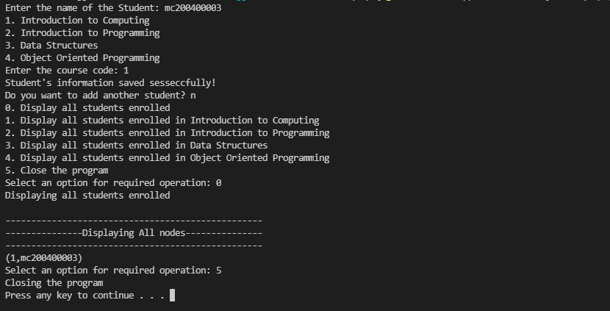
Example-2:
